Spring Sprint-Children First 5K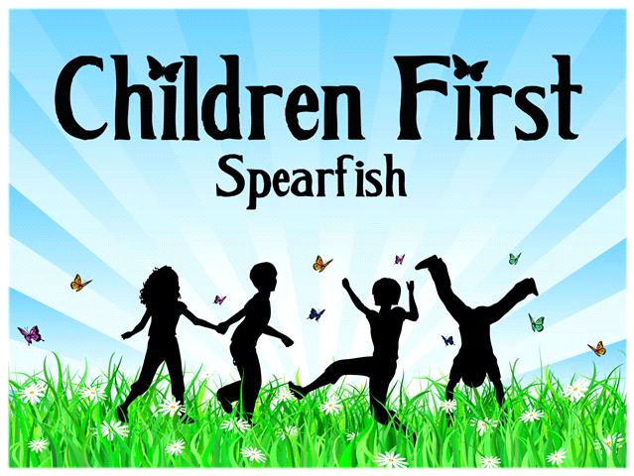
April 27th, 2019
8:00 AM
Start: Children First Parking Lot
End: Children First Parking Lot
Waiver: In consideration of your acceptance of this
entry, heirs, next-of-kin, spouse, and assigns, do
hereby waive and release any and all rights and
claims of damages, or losses against the
organizers or sponsors of this event. I have
read this document. I understand it is a release of all
claims. I understand I assume all risk inherent
in my participation in this event. I voluntarily sign
my name evidencing my acceptance of all the above provisions.

Name:
Phone:
Email:
Signature:
Date:

Please circle your entry level from the two options below:
Adult: $25.00
Child (12 years and younger): $15.00
Please make checks payable to Children First.
With each entry, one reusable water bottle will be gifted to the participant.
OPTIONAL: T-shirt order with preregistration
Please circle the size you would like to order. Each shirt is $15.00. Please only use one order form per entry. If you would like to order more T-shirts, but not participate in Spring Sprint, please fill out a separate form.

Adult (unisex sizing): XS S M L XL Kids: XS S M L XL Toddlers: 2T 3T 4T 5T

